Experiment 1: Preprocessing Impact Analysis
Aim: To study how salt-and-pepper noise and two common smoothing techniques affect image quality and the reliability of later feature detection.

Procedure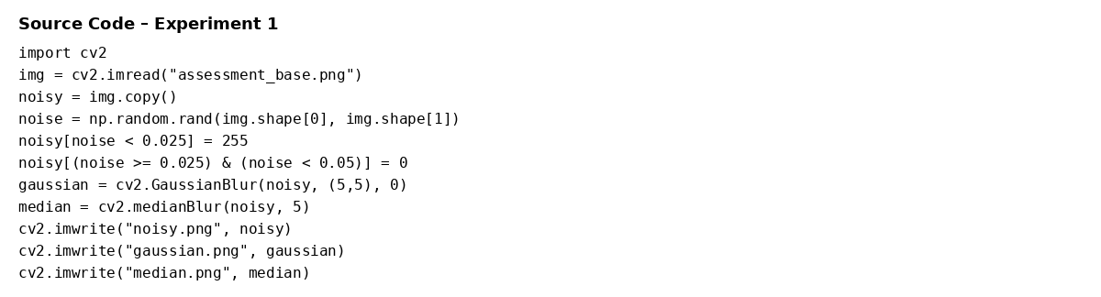
- Read the test image and introduce controlled salt-and-pepper noise.
- Apply a 5×5 Gaussian filter and a 5×5 median filter.
- Compare the noisy image with both filtered results.
- Observe noise suppression and preservation of structural boundaries.

Source Code Screenshot

Analysis / Discussion
Median filtering gives the best suppression of salt-and-pepper noise while preserving the building boundaries and window structures reasonably well. Gaussian filtering smooths the image effectively, but it also softens some fine edges. Therefore, for impulse noise, median filtering is the more suitable preprocessing choice before corner or edge detection.

Result
The preprocessing stage improves image quality and can make subsequent feature detection more stable. For salt-and-pepper noise, the median-filtered image is the most appropriate of the two tested filters.

Experiment 2: Image Representation Study
Aim: To compare color, grayscale and binary representations and determine how representation changes the information available for image analysis.

Procedure
- Read the image in color format.
- Convert the image to grayscale.
- Apply binary thresholding at intensity 127.
- Compare the structural information retained in each representation.

Source Code Screenshot
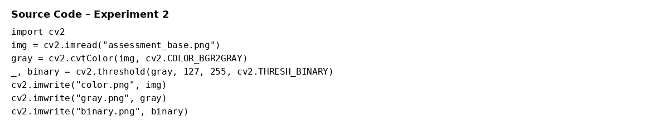

Analysis / Discussion
Color preserves the maximum information because it contains three channels. Grayscale reduces the data to one intensity channel while retaining most structure required for edges and corners. Binary representation is useful for segmentation and shape analysis, but thresholding discards intermediate intensity information and may remove weak features.

Result
Grayscale is the most practical representation for conventional edge and corner detection because it reduces computation while retaining useful intensity structure. Binary images are better suited to clearly separated regions.

Experiment 3: Edge Detection Comparison – Sobel vs Canny
Aim: To compare Sobel and Canny edge detectors on the same image and analyze their edge quality and suitability for feature extraction.

Procedure
- Convert the image to grayscale.
- Calculate horizontal and vertical Sobel gradients and combine them to obtain edge magnitude.
- Apply Canny edge detection using thresholds 100 and 200.
- Compare edge continuity and selectivity.

Source Code Screenshot
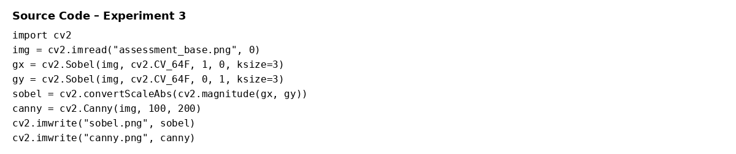

Analysis / Discussion
Sobel directly measures intensity gradients and provides edge strength and direction. Canny performs smoothing, gradient calculation, non-maximum suppression and hysteresis thresholding, so its output is thinner and more selective. In this experiment, Canny produces fewer but cleaner edge pixels than direct Sobel magnitude.

Result
Canny is preferable when clean and well-localized boundaries are required, while Sobel is useful when gradient magnitude and direction are needed for analysis.

Experiment 4: Harris Corner Detection vs FAST
Aim: To compare two feature detectors on the same image and evaluate their detected feature distribution and computational characteristics.

Procedure
- Convert the image to grayscale.
- Detect up to 100 Harris corners using a quality threshold and minimum distance.
- Detect FAST keypoints using threshold 25 and non-maximum suppression.
- Compare the locations and number of detected features.

Source Code Screenshot
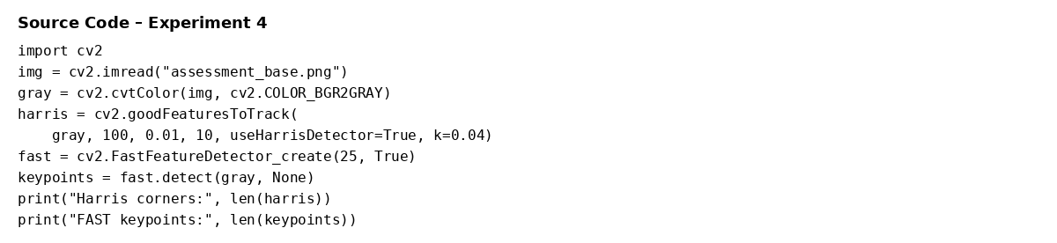

Analysis / Discussion
Harris detected 100 configured corner candidates, while FAST detected 195 keypoints. Both methods identify structural points around windows, roof boundaries and architectural intersections. Harris is based on local gradient structure, while FAST uses a circle of neighboring pixels and is designed for very rapid keypoint detection. Exact counts depend on detector parameters.

Result
Harris provides a strong corner-detection basis for structured images, whereas FAST offers a lightweight and fast alternative for applications where computational speed is important.

Experiment 5: Effect of Noise on Harris Corner Detection
Aim: To determine how image noise changes the response of a corner detector and why preprocessing is important before feature extraction.

Procedure
- Detect Harris corners on the original image.
- Add salt-and-pepper noise using the same controlled noise level as Experiment 1.
- Run the Harris detector again.
- Compare the stability and distribution of detected corners.

Source Code Screenshot
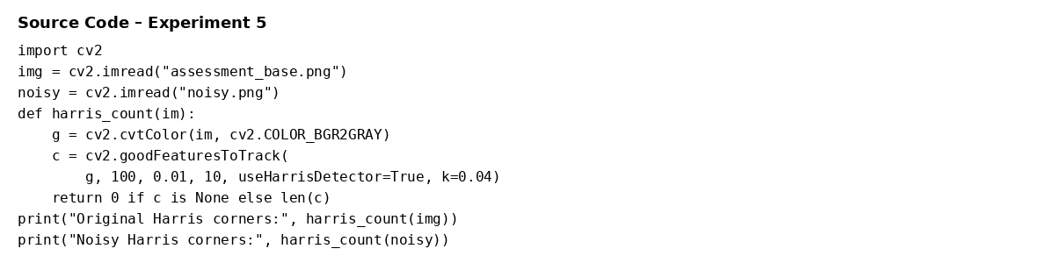

Analysis / Discussion
With the same detector settings, the original image produced 100 Harris candidates, while the noisy image reached the configured maximum of 100 candidates. The noisy result contains many additional responses caused by artificial intensity changes. This demonstrates that noise can create false corner responses and that denoising is important before feature extraction.

Result
Harris corner detection is sensitive to image noise. Appropriate preprocessing, especially denoising, improves the reliability of the detected feature set.

